USER MANUAL

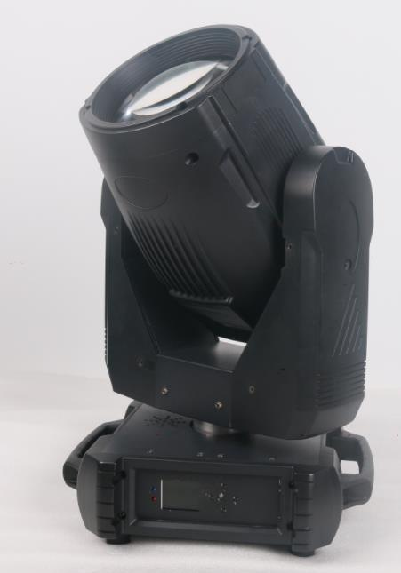

280W PRISM KING BEAM MOVING HEAD LIGHT

Please read and keep this manual carefully for further use!

Thank you for buying our professional Beam moving head.
This user manual includes important information for installation and operation, so please read this user manual carefully before installation and operation, and keep this user manual well for further use.
In order to install , operate, and maintain the lighting safety and correctly. We suggest that the installation and operation should be done by the verified technician and follow the instruction strictly.
Spare part includes:
Name | QTY | Unit
Fixture | 1 | PC
User manual | 1 | PC
Power cable | 1 | PC
bracket | 2 | PCS

Please check carefully that there is no damage caused by transportation. Should there be any, consult your local dealer.
Cautions
Before delivery, this device has passed strict inspection, Please follow the user manual strictly for operation, if this fixture is damaged by improper operation and mistake, the fixture will be out of warranty, and manufacture or dealer won’t be responsible for it. In case of any technology change in this manual,we won’t advise in further .



CAUTION!

Keep this device away from rain and moisture!

Unplug mains lead before opening the housing!

Warning!

Silkscreen symbol on light
Damages caused by the disregard of this user manual are not subject to warranty. The dealer will not accept liability for any resulting defects or problems.

Installation
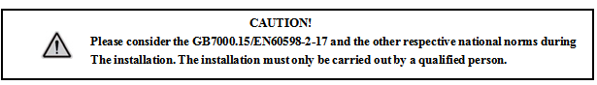

► This fixture is not suitable for direct installation on combustible material surface, please keep the fixture surface at least 0.5m from any combustible material.

► If you use the quick lock cam in hanging up the fixture, please make sure the quick lock fasteners turned in the quick lock holes correctly.
►The applicable temperature for the fixture is between -25°C to 45°C. Do not use the lighting under or above this temperature range.
►The truss for hanging the fixture should be able to hold 10 times weight of this fixture and no deformation after 1 hour hang.
►Please don’t stand under the fixture when install, uninstall, move or repair the fixture.
►Please ensure the light is connected correctly and invite professional technician to check and confirm the electrical data before installation.
►Please invite professional technician to check the fixture and installation each year.
Rigging：
Clamp
Bracket

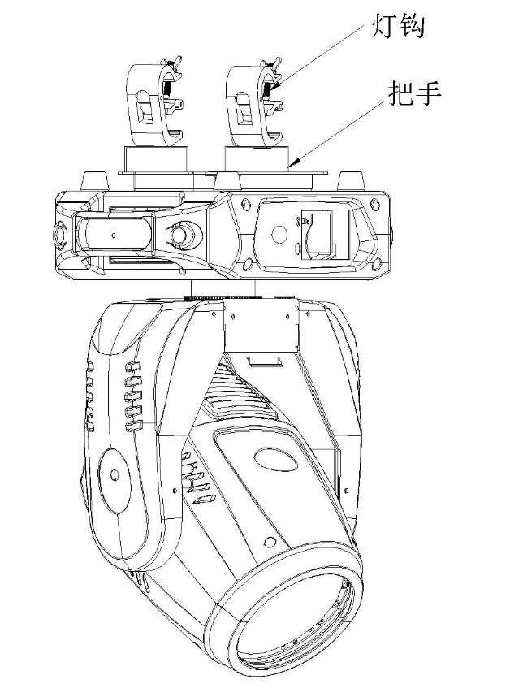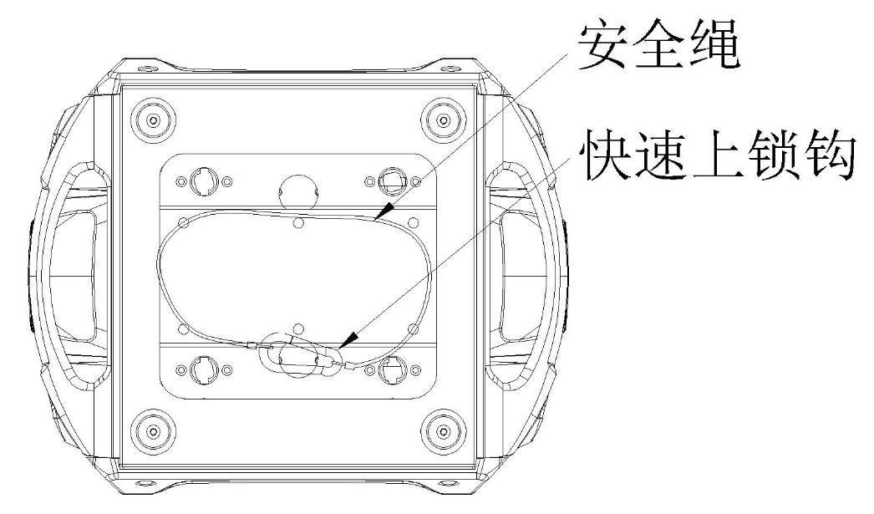
Safety rope

Quick lock

Insert the quick-lock fasteners of the first holder into the respective holes on the bottom of the device.Tighten the quick-lock fasteners fully clockwise.
Fix the clamp on truss or other fixture bracket.
Pull the safety rope through the holes on the bottom of the base and fasten it on the truss or other fixing point.
Note:This step is quite important to ensure that fixture will not drop down for the clamp damage.

Product specification

1. Voltage：100-240V，50/60HZ；
2. Power Consumption：300W；
3. average lifetime:2000hours； Color Temp: 8000K；
4.Pan：540°(16bit) electronic error correction；
5.Tilt：270° (16bit) electronic error correction；
6.Color wheel:14 colors+open
7.Gobo wheel:13gobos+open; including 3 mirror gobos
8.Prism:5 prism effects
9.Frost and 6-color wheel effect,electronic focus
10. Electrical dimming：0%~100%；support strobe at various speeds, strobe color marco
11. Beam angle：1.8º
12. Over-heat protection；Display：LCD
13. IP rate:IP20；
14.Product size：327*268*490mm；
15.outer carton size: 405*370*53mm；
16.N.W：14.5KG；

Display and operation

Touch button | Function
Up | Option, Edit
Left | Option, Edit
Right | Option, Edit
OK | Enter to edit or confirm

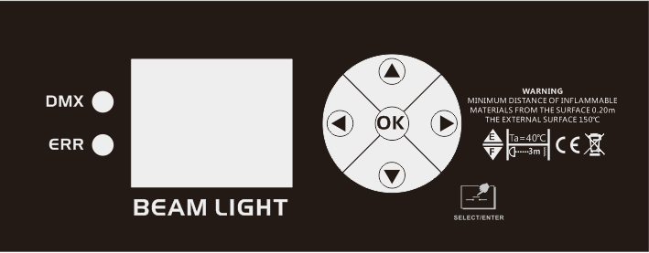

Sub-menu operation mainly by touch, if using by Roller, operation instruction as below

<Up> : turn up; <Down> ：turn down; <OK> ： enter or confirm
Menu operation

MAIL
MENU ----Setting ----running mode
----DMX setting
----DMX channel mode
----sound sensitivity adjustment -2/+2
----X reverse
----Y reverse
----Y.X exchange
---- XY encode
---- RDM
----DMX lost
----display protection
----lamp ON
----factory default
---manual
---system ----DMX channel value monitor
----system error record
----software version
----date
----turn on time
---senior ----sensor monitoring
----reset correction
----gobo, color correction
---reset ----all motors reset

--lamp
--English/Chinese
--display reverse

Manual operation
Press “OK” button to edit, choose digit at hundred place, choose UP or DOWN button to change the value, press OK to confirm.

System info
Option | Details
software version | the current software version
DMX channel value | enter the sub-menu, show channel value or percentage
system error record | if the ERROR indicator is ON, it means the fixture has operation error, can enter the sub-menu to check and cancel the record
Error | Details
motor reset failure，serial port error | Driving PCB no feedback. the connection between display PCB and driving PCB has problem, or driving PCB problem
Pan reset error | Pan photo-electrical switch or Pan motor problem
Tilt reset error | Tilt photo-electrical switch or Tilt motor problem
Pan Hall error | Pan Hall error
Tilt Hall error | Tilt Hall error
color wheel reset failure | color wheel hall or color wheel motor problem
gobo wheel reset failure | gobo wheel hall or gobo wheel motor problem
focus reset failure | focus hall or focus motor error
lamp control failure | lamp ON/OFF error, lamp ballast or lamp have problem

Senior
A password is set up to prevent from wrong operation by unprofessional people. Default password is “******”. press “OK” for password verification.
Option | Details
reset | Enter the sub-menu, adjust the Pan/Tilt motor's reset position, the adjustment range is -128~+127，+0 means no adjustment
sensor monitoring | monitor the status of all sensor and Hall switch

Gobo wheel
White 5
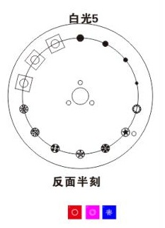

color sequence
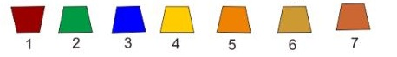
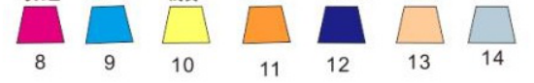

Six-color effect
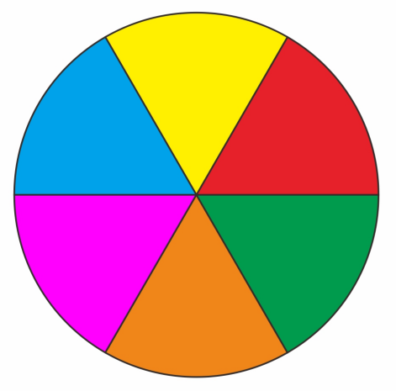
18 DMX channel
18CH | Function | Value | Details | Remarks
CH1 | color wheel | 255 | high speed rotation | gobo flowing
CH1 | color wheel | …… | …… | gobo flowing
CH1 | color wheel | 191 | low speed rotation | gobo flowing
CH1 | color wheel | 190 | low speed rotation | gobo flowing
CH1 | color wheel | …… | …… | gobo flowing
CH1 | color wheel | 150 | high speed rotation
CH1 | color wheel | 145-149 | color 14+ white
CH1 | color wheel | 140 | color 14
CH1 | color wheel | 135 | color 13 +color 14 | the value is 5N
CH1 | color wheel | 130 | color 13 | the value is 5N
CH1 | color wheel | 125 | color 12 +color 13 | the value is 5N
CH1 | color wheel | 120 | color 12 | the value is 5N
CH1 | color wheel | 115 | color 11 +color 12 | the value is 5N
CH1 | color wheel | 110 | color 11 | the value is 5N
CH1 | color wheel | 105 | color 10 +color 11 | the value is 5N
CH1 | color wheel | 100 | color 10 | the value is 5N
CH1 | color wheel | 95 | color 9 +color 10 | the value is 5N
CH1 | color wheel | 90 | color 9 | the value is 5N
CH1 | color wheel | 85 | color 8 +color 9 | the value is 5N
CH1 | color wheel | 80 | color 8 | the value is 5N
CH1 | color wheel | 75 | color 7 +color 8 | the value is 5N
CH1 | color wheel | 70 | color 7 | the value is 5N
CH1 | color wheel | 65 | color 6 +color 7 | the value is 5N
CH1 | color wheel | 60 | color 6 | the value is 5N
CH1 | color wheel | 55 | color 5 +color 6 | the value is 5N
CH1 | color wheel | 50 | color 5 | the value is 5N
CH1 | color wheel | 45 | color 4 +color 5 | the value is 5N
CH1 | color wheel | 40 | color 4 | the value is 5N
CH1 | color wheel | 35 | color 3 +color 4 | the value is 5N
CH1 | color wheel | 30 | color 3 | the value is 5N
CH1 | color wheel | 25 | color 2 +color 3 | the value is 5N
CH1 | color wheel | 20 | color 2 | the value is 5N
CH1 | color wheel | 15 | color 1 +color 2 | the value is 5N
CH1 | color wheel | 10 | color 1 | the value is 5N
CH1 | color wheel | 5 | white +color 1 | the value is 5N
CH1 | color wheel | 0 | white | the value is 5N
CH2 | strobe | 252-255 | shutter open | controlled by dimmer channel
CH2 | strobe | 239-251 | High speed random strobe
CH2 | strobe | 226-238 | middle speed random strobe
CH2 | strobe | 213-225 | low speed random strobe
CH2 | strobe | 208-212 | shutter open | controlled by dimmer channel
CH2 | strobe | 207 | Pulse strobe
CH2 | strobe | …… | ……
CH2 | strobe | 108 | Pulse strobe
CH2 | strobe | 104-107 | shutter open | controlled by dimmer channel
CH2 | strobe | 103 | strobe
CH2 | strobe | …… | ……
CH2 | strobe | 4 | strobe
CH2 | strobe | 0-3 | shutter off
CH3 | dimmer | 255 | dimmer 100%
CH3 | dimmer | …… | ……
CH3 | dimmer | 0 | dimmer 0%
CH4 | gobo wheel | 255 | gobo 13 shake at high speed | the value is 5N
CH4 | gobo wheel | …… | ……
CH4 | gobo wheel | 251 | gobo 13 shake at low speed
CH4 | gobo wheel | …… | ……（gobo 2 to gobo 12）
CH4 | gobo wheel | 195 | gobo 1 shake at high speed
CH4 | gobo wheel | …… | ……
CH4 | gobo wheel | 191 | gobo 1 shake at low speed
CH4 | gobo wheel | 190 | high speed rotation（clockwise）
CH4 | gobo wheel | …… | ……
CH4 | gobo wheel | 135 | low speed rotation（clockwise）
CH4 | gobo wheel | 130-134 | stop
CH4 | gobo wheel | 129 | low speed rotation（anticlockwise）
CH4 | gobo wheel | …… | ……
CH4 | gobo wheel | 70 | high speed rotation（anticlockwise）
CH4 | gobo wheel | 65-69 | gobo 13
CH4 | gobo wheel | 60 | gobo 12
CH4 | gobo wheel | 55 | gobo 11
CH4 | gobo wheel | 50 | gobo 10
CH4 | gobo wheel | 45 | gobo 9
CH4 | gobo wheel | 40 | gobo 8
CH4 | gobo wheel | 35 | gobo 7
CH4 | gobo wheel | 30 | gobo 6
CH4 | gobo wheel | 25 | gobo 5
CH4 | gobo wheel | 20 | gobo 4
CH4 | gobo wheel | 15 | gobo 3
CH4 | gobo wheel | 10 | gobo 2
CH4 | gobo wheel | 5 | gobo 1
CH4 | gobo wheel | 0 | white
CH5 | prism 1 | 200-255 | prism 2
CH5 | prism 1 | 100-199 | prism 1
CH5 | prism 1 | 0-99 | no effect
CH6 | prism 1 rotation | 255 | high speed rotation（clockwise）
CH6 | prism 1 rotation | …… | ……
CH6 | prism 1 rotation | 193 | low speed rotation（clockwise）
CH6 | prism 1 rotation | 191-192 | stop
CH6 | prism 1 rotation | 190 | low speed rotation（anticlockwise）
CH6 | prism 1 rotation | …… | ……
CH6 | prism 1 rotation | 127 | high speed rotation（anticlockwise）
CH6 | prism 1 rotation | 0-127 | adjust angle
CH7 | prism 12 | 200-255 | prism 5
CH7 | prism 12 | 101-199 | prism 4
CH7 | prism 12 | 10-100 | prism 3
CH7 | prism 12 | 0-9 | no effect
CH8 | prism 2 rotation | 255 | high speed rotation（clockwise）
CH8 | prism 2 rotation | …… | ……
CH8 | prism 2 rotation | 193 | low speed rotation（clockwise）
CH8 | prism 2 rotation | 191-192 | stop
CH8 | prism 2 rotation | 190 | low speed rotation（anticlockwise）
CH8 | prism 2 rotation | …… | ……
CH8 | prism 2 rotation | 127 | high speed rotation（anticlockwise）
CH8 | prism 2 rotation | 0-127 | adjust angle
CH9 | six color effect | 128-255 | six color effect
CH9 | six color effect | 0-127 | no six color effect
CH10 | focus | 255 | focus 100%
CH10 | focus | …… | ……
CH10 | focus | 0 | focus 0%
CH11 | focus fine | 0-255 | focus fine
CH12 | pan | 0-255 | 0-540 degree
CH13 | pan fine | 0-255 | 0-1 degree
CH14 | tilt | 0-255 | 0-270 degree
CH15 | tilt fine | 0-255 | 0-1 degree
CH16 | XY speed | 0-255 | from fast to slow
CH17 | frost | 128-255 | frost
CH17 | frost | 0-127 | no frost
CH18 | lamp control and reset | 245-250 | all motors reset | lamp ON/OFF after 5 seconds
CH18 | lamp control and reset | 211-244 | no function | lamp ON/OFF after 5 seconds
CH18 | lamp control and reset | 200-210 | lamp on | lamp ON/OFF after 5 seconds
CH18 | lamp control and reset | 111-199 | no function | lamp ON/OFF after 5 seconds
CH18 | lamp control and reset | 100-110 | lamp off | lamp ON/OFF after 5 seconds
CH18 | lamp control and reset | 0-99 | no function | lamp ON/OFF after 5 seconds

DMX-512 connection

Connect the provided XLR cable to the male 3-pin XLR output of your controller and the other side to the female 3-pin XLR input of the light.then connect the DMX signal to the first fixture to the 2nd fixture, after all fixtures are connected,

The signal cable should be two - core with screened cable with XLR input and output connectors. Please refer to the diagram below

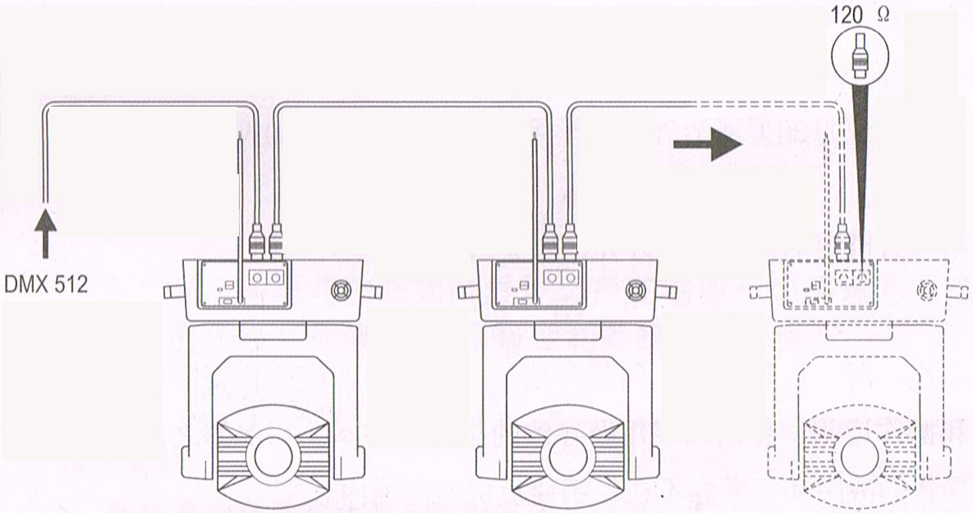

DMX terminator connection
If there are many lines or lights, it is recommended to use a DMX terminator to prevent DMX signal corruption, the DMX terminator is an simple XLR plug with a 120 Ω resistor connected between pins 2 and 3,which is then plugged into the output XLR socket of the last fixture in the chain.
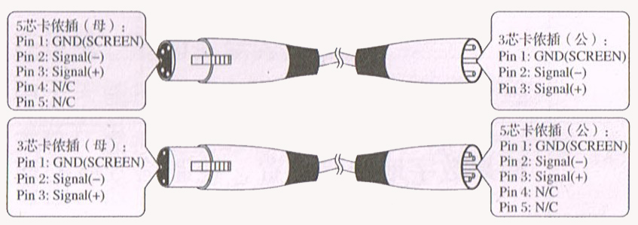
3-Pins connection
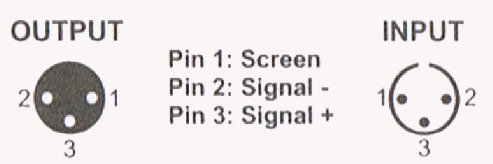
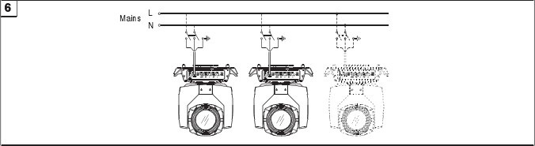
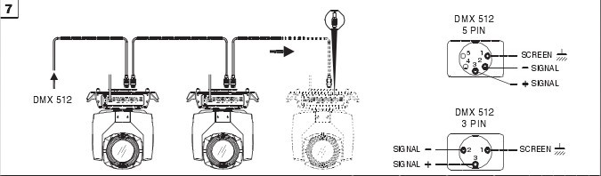

Cleaning and maintenance

Cleaning should be performed every 15-day period, by using a sponge which is dipped with alcohol, rather than wet cloth or other chemical liquid, to clean the mirror.

Cut off power before cleaning and maintenance!
CAUTION

Attention

Do not see directly light source when open the light, and make sure power off before do any installation or maintenance.



 Wires connection must be done professional person!
CAUTION

Cautions
Before delivery, this device has passed strict inspection, Please follow the user manual strictly for operation, if this fixture is damaged by improper operation and mistake, the fixture will be out of warranty, and manufacture or dealer won’t be responsible for it. In case of any technology change in this manual,we won’t advise in further .

Common issues instruction

Issues | Solve instruction
No power | Check power’s voltage
When power in, output light but the device cannot accept control signal | Check address setting and the control DMX cable connection well or not
The effect have light shadow | Check electronic focus DMX channel value, does suitable distance
Power down | The lamp maybe arrived end of using life, should change new lamp, and also check light source cleaning or not
Note: the maintenance should be done by the verified technician.

